Figured out a way. Two approaches to create the source file:
Create source DB file by:
- Using PyCharm dbtool to dump SQL insert tables, then join them using Python.
Dump all data from the current DB as SQL inserts. This will create a SQL insert file from every data table.
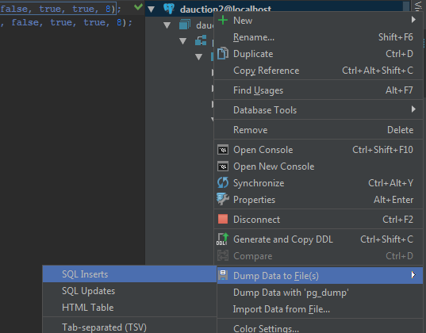
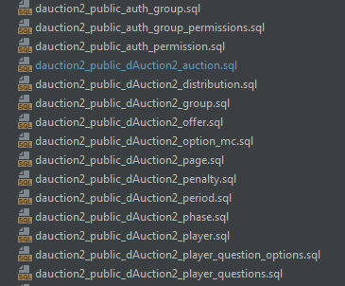
Use Python script merge_sql.py (currently in anl/data/02_11_2017/sql/) to join them into one big SQL insert file (script makes sure, that they will be inserted in the DB in order).
- SQL dump command
Run
pg_dump "dbname='dauction2' user='dauction' password='dauction' host='localhost'" --inserts --data-only --no-owner --no-security-labels -x > db.sql
on SSH Vagrant -> it creates DB dump of current DB named db.sql in main Vagrant folder,
Load the resulting file
Then load this file of SQL inserts back to db using this console command on SSH Vagrant:
psql "dbname='dauction2' user='dauction' password='dauction' host='localhost'" -f db.sql
This has but one drawback, if you CHANGE a model (mainly remove some field, I had to change files from Wednesday with the removal of treatment.seed and auction.seed) between runs of the experiment you will have to manually correct SQL insert file to fit a new DB schema.
I created file of Thursday "pilot" using method 1, you can load it and play with it. Use
psql "dbname='dauction2' user='dauction' password='dauction' host='localhost'" -f anl/static/data/02_11_2017/sql/complete.sql
on SSH Vagrant to import it 
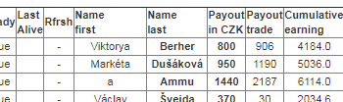
DB command that flushes content of all used tables (useful for testing)
TRUNCATE "dAuction2_distribution","dAuction2_timer", "dAuction2_page", "dAuction2_group", "dAuction2_period", "dAuction2_player_stats", "dAuction2_penalty", "dAuction2_player_questions", "dAuction2_question", "dAuction2_voucher", "dAuction2_voucherre", "dAuction2_player_question_options", "dAuction2_option_mc", "dAuction2_offer", "dAuction2_auction", "dAuction2_player", "dAuction2_user", "dAuction2_phase", "dAuction2_user_groups", "dAuction2_treatment", "dAuction2_user_user_permissions" CASCADE

